# **WEEK 0**

**NAME: SRI DURGA R**

**ROLL NO: 241801273**

**Q1: Calculate Area and Perimeter**

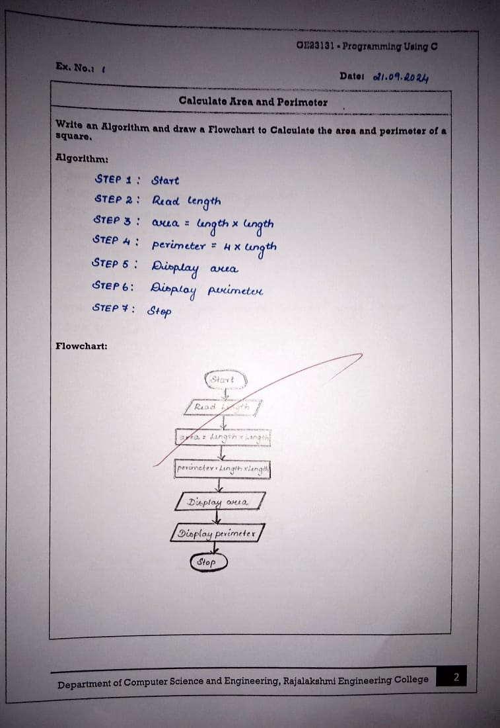

**Q2:** **Days to Year Conversion**

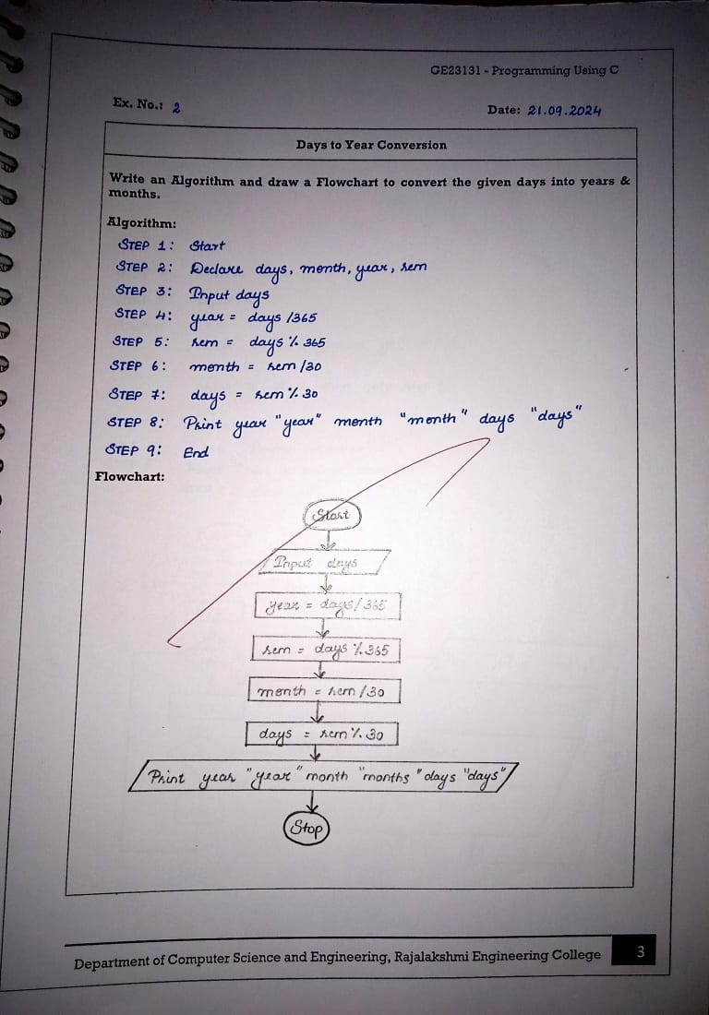

**Q3: Prime Number**

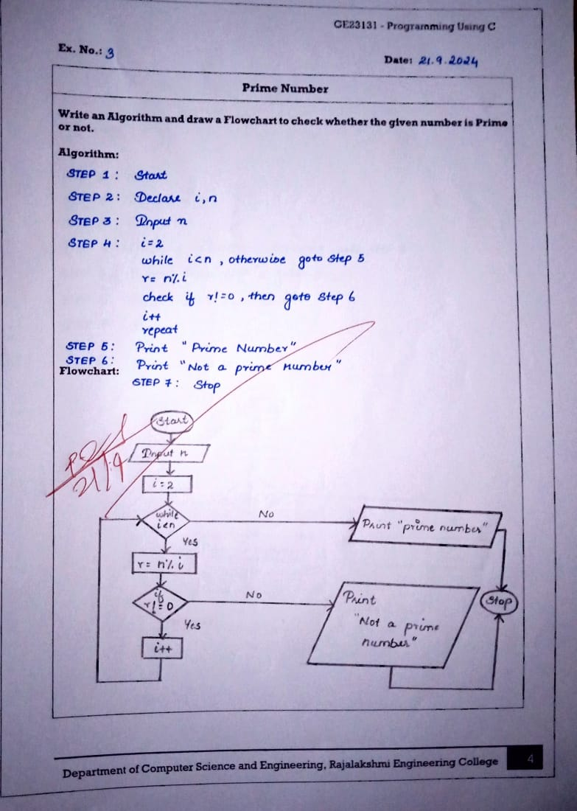

**Q4:** **Leap Year**

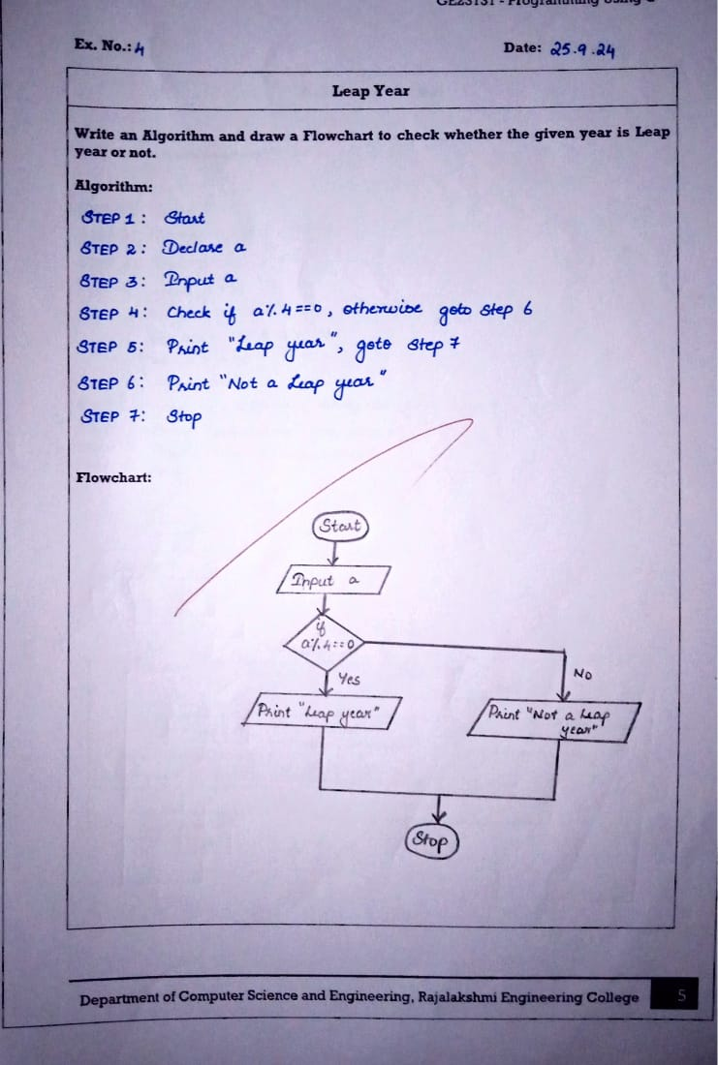

**Q5: Palindrome Number**

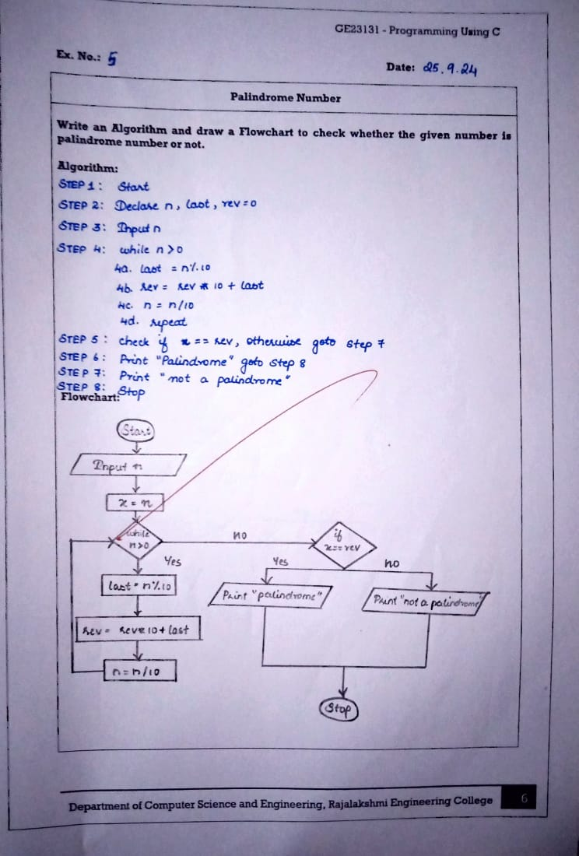

**Q6:** **Sum of Digits**

